Palindrome Partitioning
Problem Statement: You are given a string s, partition it in such a way that every substring is a palindrome. Return all such palindromic partitions of string s. A palindrome string is a string that reads the same backward as forward.
Examples
Input: s = “aab”
Output: {["a","a","b"], ["aa","b"]]
Explanation: The first answer is generated by making three partitions. The second answer is generated by making two partitions.

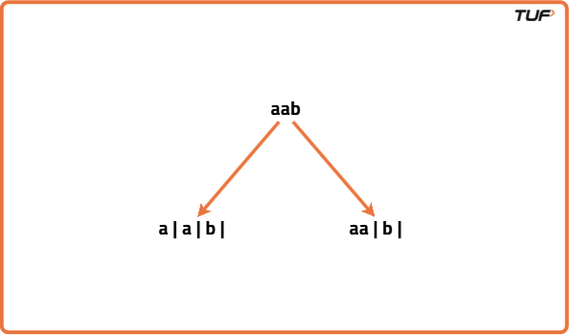

Input: s = “aabb”
Output: [[“a”,”a”,”b”,”b”], [“aa”,”bb”], [“a”,”a”,”bb”], [“aa”,”b”,”b”]]
Explanation : Below are all the partitioning.

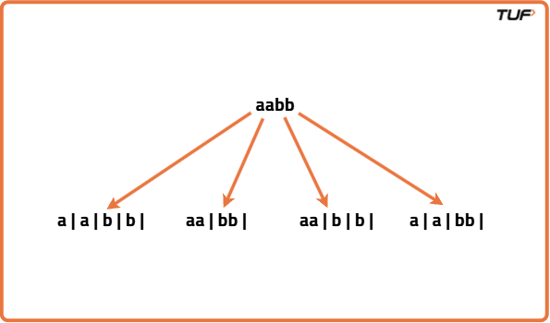

Algorithm
The initial idea will be to make partitions to generate substring and check if the substring generated out of the partition will be a palindrome. Partitioning means we would end up generating every substring and checking for palindrome at every step. Since this is a repetitive task being done again and again, at this point we should think of recursion. The recursion continues until the entire string is exhausted. After partitioning, every palindromic substring is inserted in a data structure. When the base case has reached the list of palindromes generated during that recursion call is stored in our answer.
- Use backtracking to explore all possible ways to partition the string.
- Start from index 0 and try all possible substrings from the current index to the end.
- For each substring, check if it is a palindrome.
- If the substring is a palindrome, include it in the current partition and recursively call the function for the remaining string.
- Backtrack by removing the last added substring and trying the next possible partition.
- Continue this process until you reach the end of the string.
- Store all valid partitions (where all substrings are palindromes) in the result.
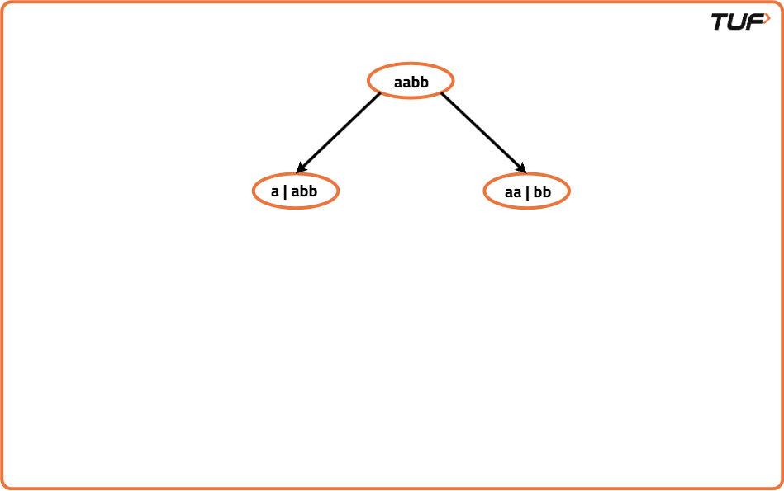
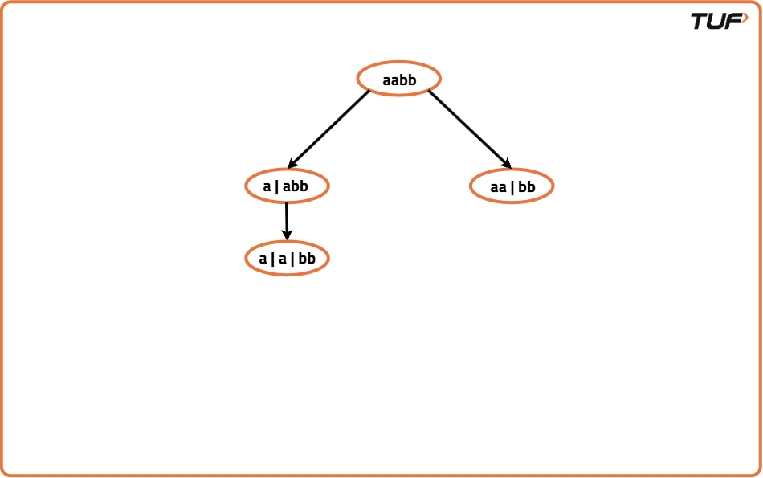
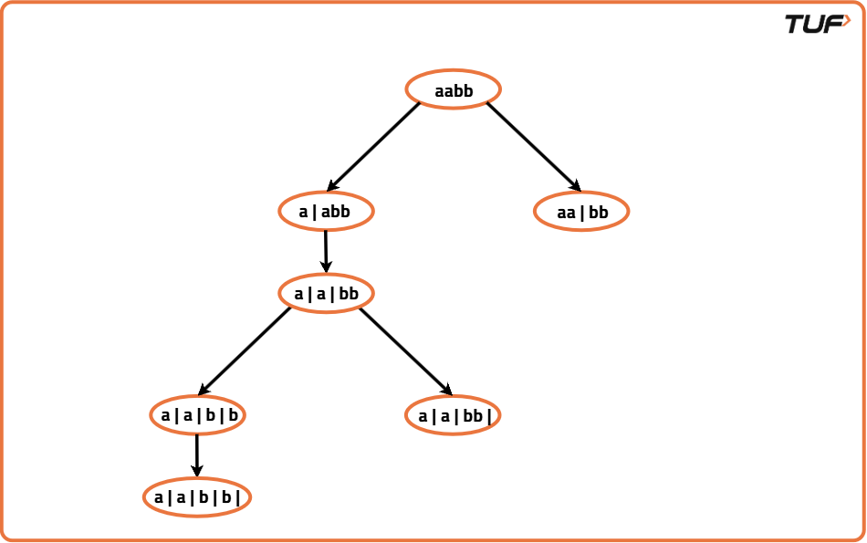
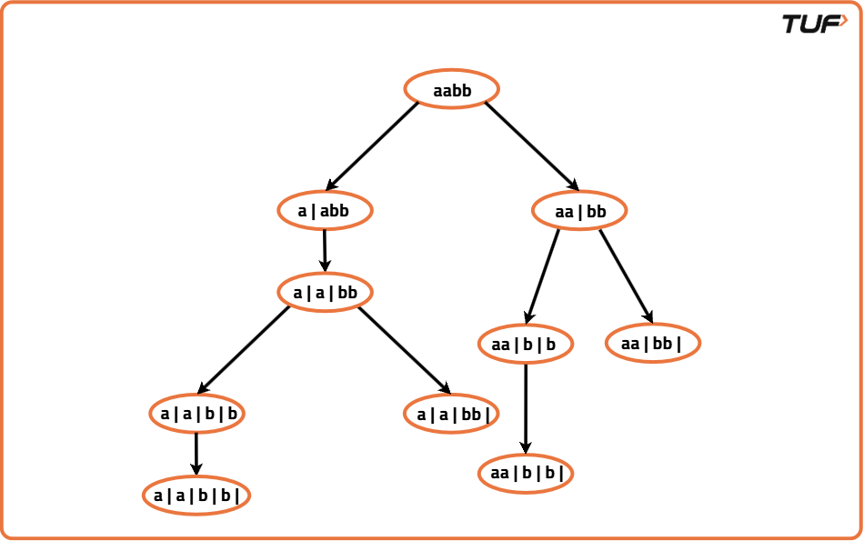

Code
import java.util.*;

class Solution {
// Function to check if a given substring is a palindrome
private boolean isPalindrome(String s, int start, int end) {
// Loop while start is less than end
while (start < end) {
// If characters at start and end are not equal, it's not a palindrome
if (s.charAt(start) != s.charAt(end)) return false;
// Move start forward and end backward
start++;
end--;
}
// If all characters matched, it's a palindrome
return true;
}

// Backtracking function to generate all possible palindrome partitions
private void backtrack(int index, String s, List<String> path, List<List<String>> res) {
// If index reached the end of string, add the current path to result
if (index == s.length()) {
res.add(new ArrayList<>(path));
return;
}

// Try all possible substrings starting from index
for (int i = index; i < s.length(); i++) {
// Check if current substring is palindrome
if (isPalindrome(s, index, i)) {
// Add substring to current path
path.add(s.substring(index, i + 1));
// Recur for the next index
backtrack(i + 1, s, path, res);
// Backtrack by removing the last added substring
path.remove(path.size() - 1);
}
}
}

// Main function to return all palindrome partitions
public List<List<String>> partition(String s) {
// Initialize result and temporary path
List<List<String>> res = new ArrayList<>();
List<String> path = new ArrayList<>();
// Start backtracking from index 0
backtrack(0, s, path, res);
return res;
}
}

Complexity Analysis
Time Complexity: O(2^N * N), we create all possible partitions and check whether they are palindrome or not.
Space Complexity: O(2^N * N) + O(N), additional space used to store all possible results and auxiliary stack space.

